# **Ken Briggs Video Transcript**

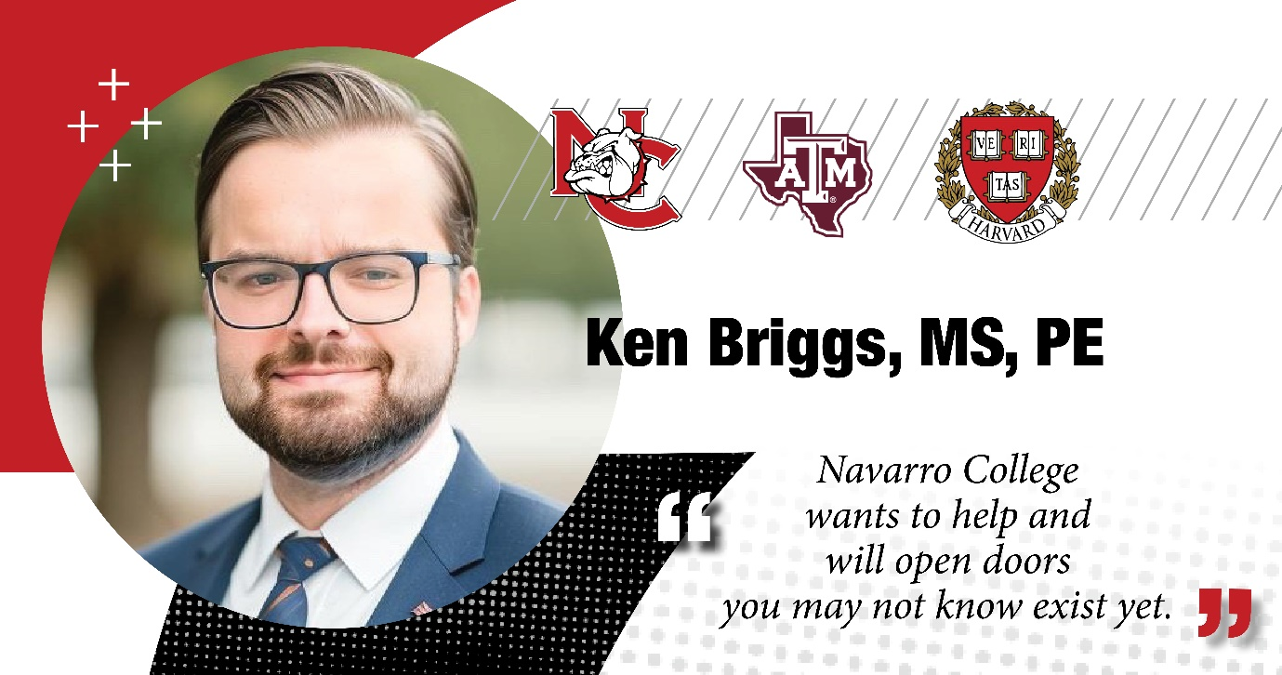

**Ken Briggs**: I grew up in Navarro County on a ranch south of Rice, Texas. And as a kid, uh, Navarro College was a really early part of my life experience.

You know, I took field trips down to the planetarium, uh, did space camp in the summer. Uh, so it was a really a natural place to go when I decided to enroll in college at the young age of 16. And right now, um, after A&M, uh, went to San Antonio to work as a consulting engineer.

Um, after leaving that role, I've been working with startups in energy and construction for the last few years, and, uh, recently just started a master's degree program at the Harvard Extension School to learn more about International Relations and Policy, which are two areas I've always had a strong passion and interest.

Yeah, I, I grew up quick, more quickly than people my age and especially being, you know, there with adults who, in a lot of cases, who were going back to school or getting their first degree, and, you know, kind of seeing that experience and stepping out kind of the more sheltered experience. And I think that was very important for me.

Um, I would say (pause)

For me, all the instructors that I had were very supportive and and helped me with anything. I one of my, uh, actually the most important was, um, Michael Prim, an English professor. And he.

About the Navarro experience is because they have the dorms, there was a lot of international students there and you know, young kid grew up in Navarro County, right? (Laugh) I had never met someone from another country, right? (Laugh)

And and so that was a great part of the experience - was just meeting with them. And you know, one of my coworkers was, two of them were from Zimbabwe, another was from West Africa. I had another classmate from Nigeria, another one from Brazil.

Um, so I think that was a great part of the experience that I don't think a lot of people know about Navarro.