# **Monique Brand Video Transcript**

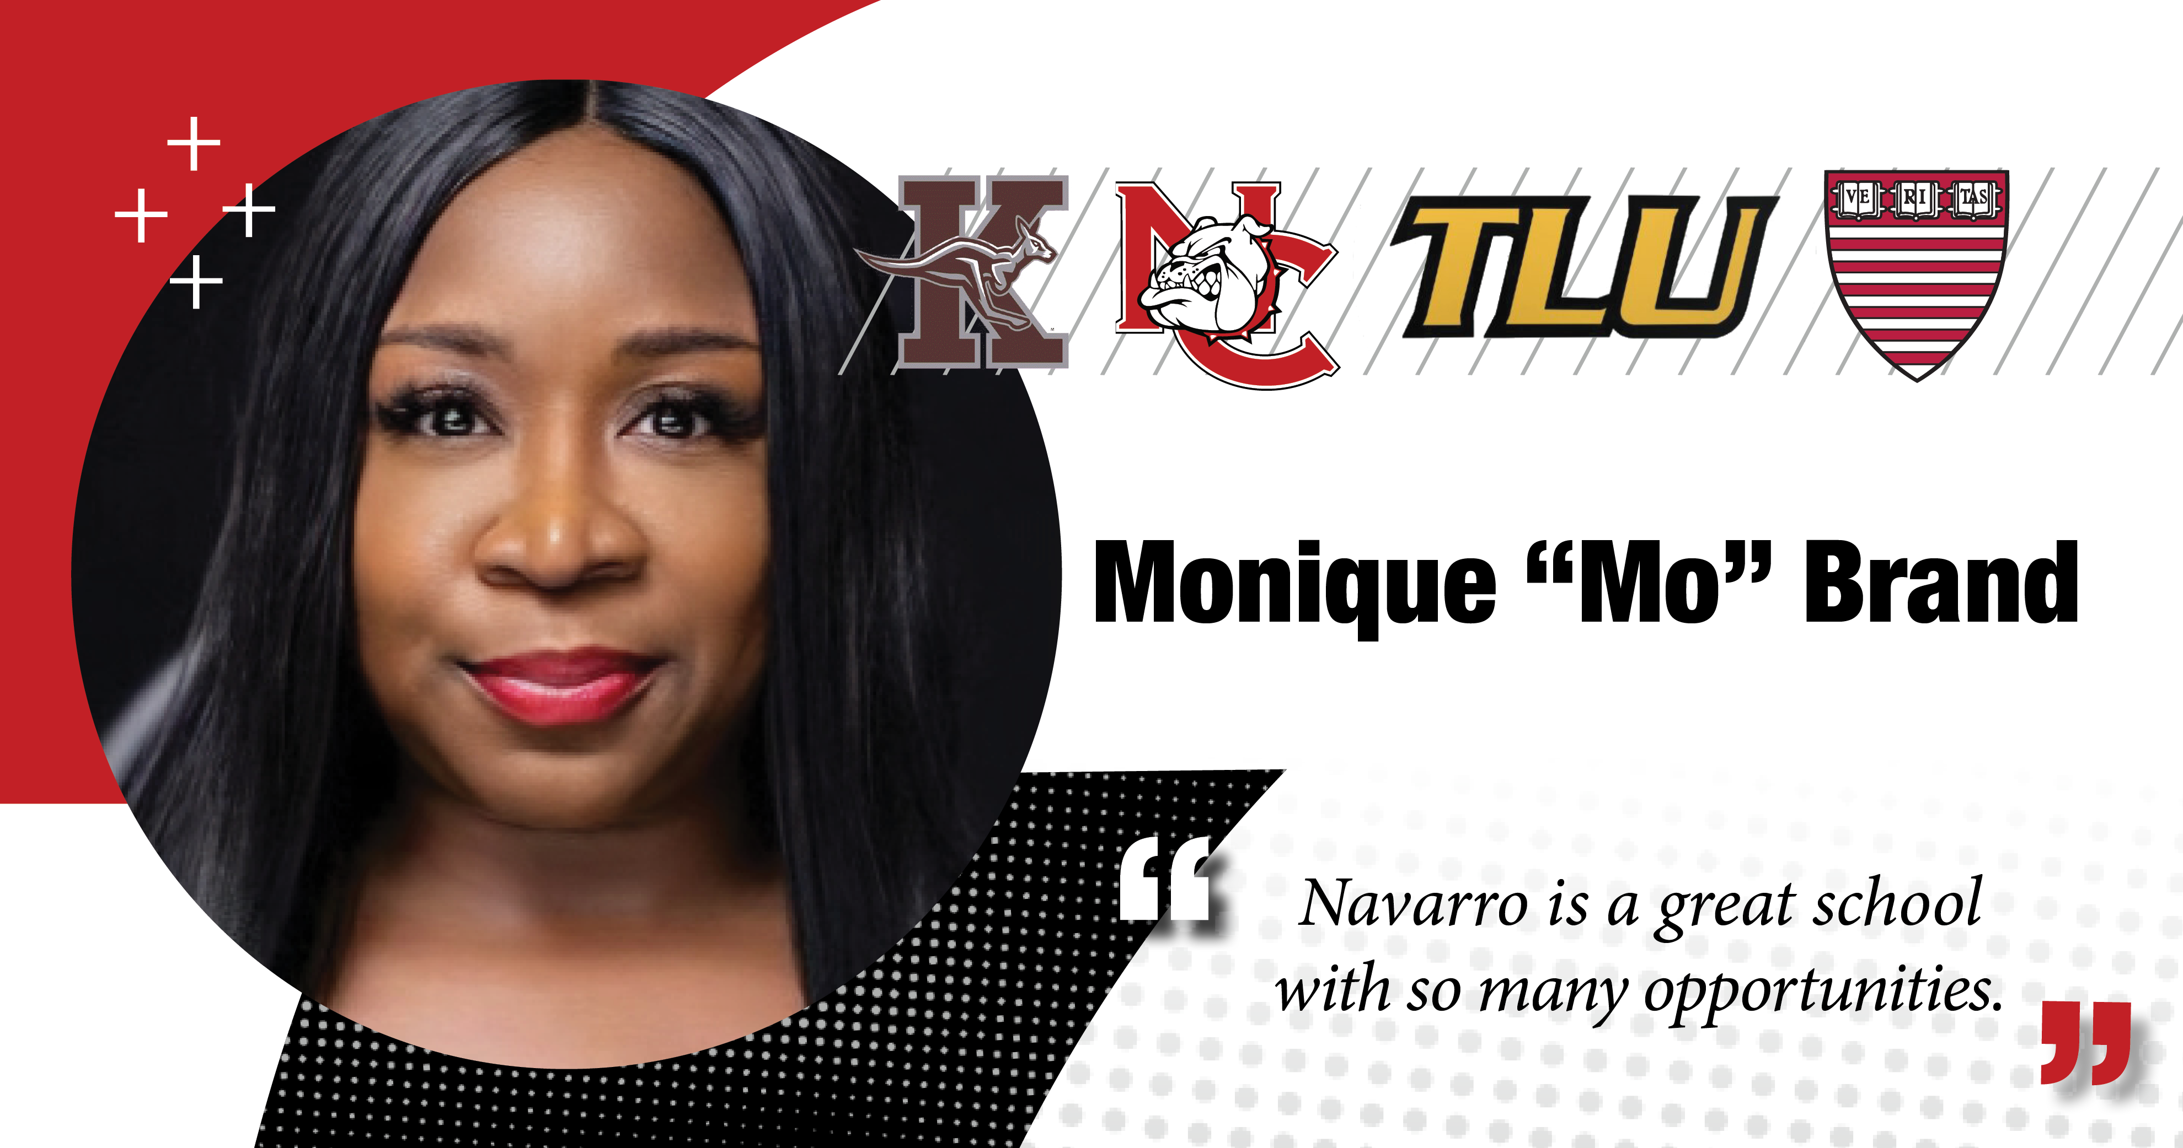

**Monique Brand:** Hi.I'm Monique Brand, not just a journalist with 16 years under her belt, but a proud Navarro College Bulldog, Class of 2004.

While my days at Navarro were very short lived, the results were long lasting.

The afternoons near the Clock Tower - studying like crazy to the church ladies cooking holiday meals for those who made their campus their home away from home.

To the professors who care. To admissions counselors who actually listen, I'm forever grateful for this experience.

I encourage anyone who wants to attend a small campus that resembles a D2 college to check out Navarro. Go Bulldogs.