# **Russell Montfort Video Transcript**

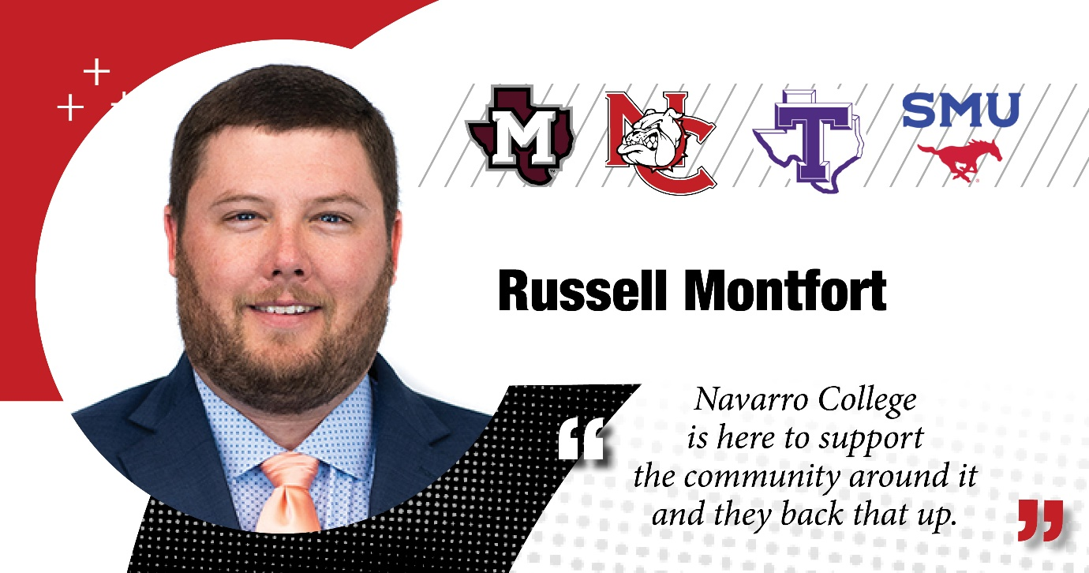

**Mike Monfort:** I’m Mike Montfort. I'm a lender at First State Bank in Corsicana, Texas, where I'm also a Vice President.

I graduated Navarro College in 2006 and later went on to Tarleton State to finish up my graduate degree.

Um, my experience at Navarro College was one that was very, uh, easy, uh, for a student to transition.

Uh, I was involved with some dual credit through my high school at Mildred, uh, which made that an easy stepping stone into going to class full-time and then on to Tarleton State, which all of my classes transferred pretty easily down there to Tarleton.

Uh, as I've gone on professionally, Navarro College has been a great community partner and it's really nice to see as a banker, you know, I'm involved in a lot of different things in the community, different boards. And Navarro College has some representatives that also serve on those boards with us.

Um, and we might be in a room somewhere and somebody offers a facility or services or folks to come and help at an event, which is great for our community.

And it's, it's really nice to see a community college that, that really tries to back the community that it's in.

Um, it's, you know, it's, it's a great place to, to learn. It's a beautiful campus. Um, the school, the organization themselves always seem like they're trying to just make themselves better, which is awesome.

Um, but I'm, I'm really, really proud to have been a part of it, to have gone to school there. And I'm really proud to serve on various boards around the community with uh, folks that that work for Navarro College.